SAP EWM – RF Screen Framework

**Create custom screens for creating the Handling Units with the Supplier scanned handling unit number followed by its GR posting and Creation/Confirmation of Warehouse Task.**

Create custom function group/required sub screens with layouts as shown below and add the below include program in it: INCLUDE /scwm/irf_sscr 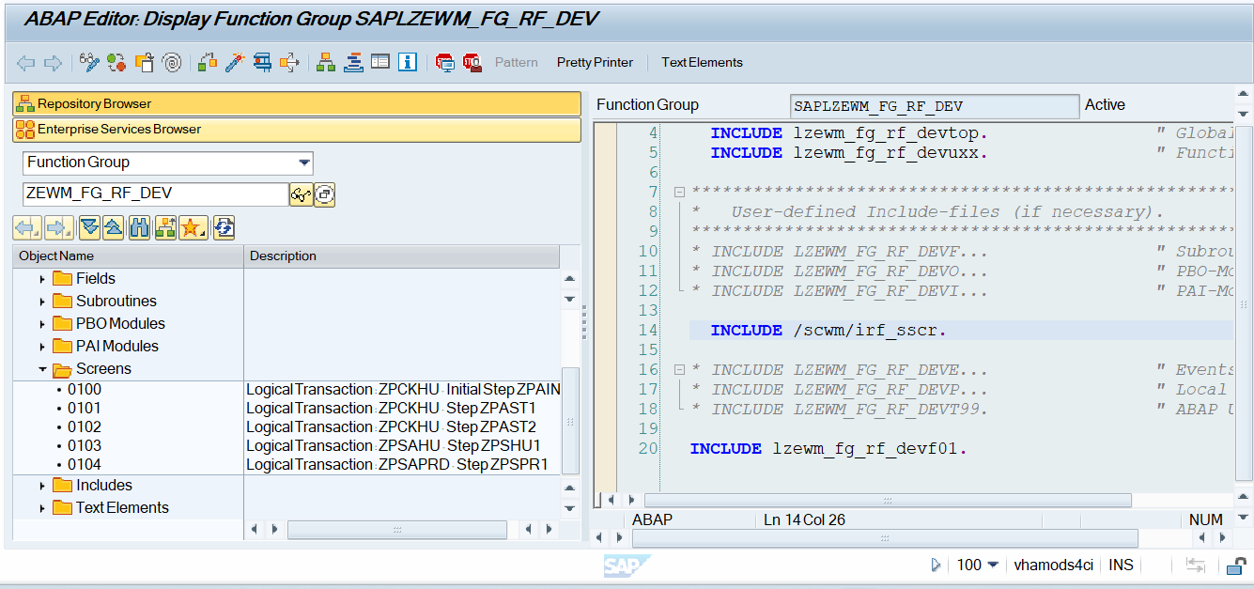

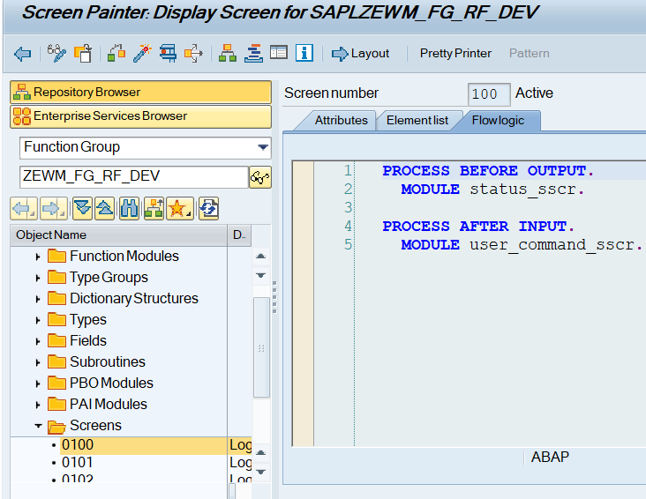

Add below shown buttons as per requirement in RF Menu Manager in below SPRO path:

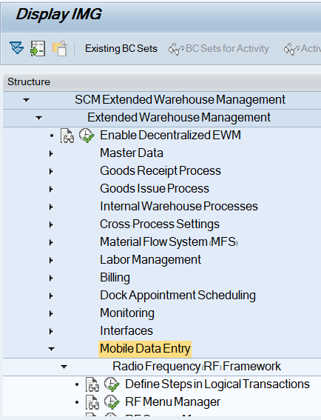

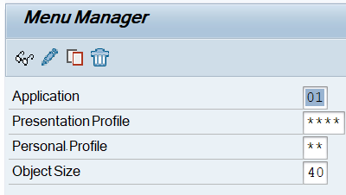

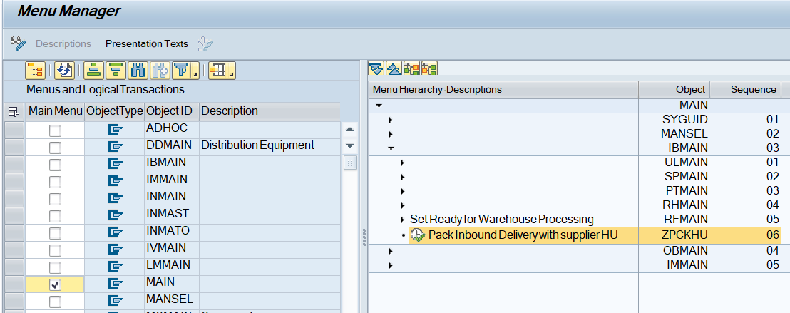

Configuration done in Define steps in Logical Transaction:

* Define Logical Transaction

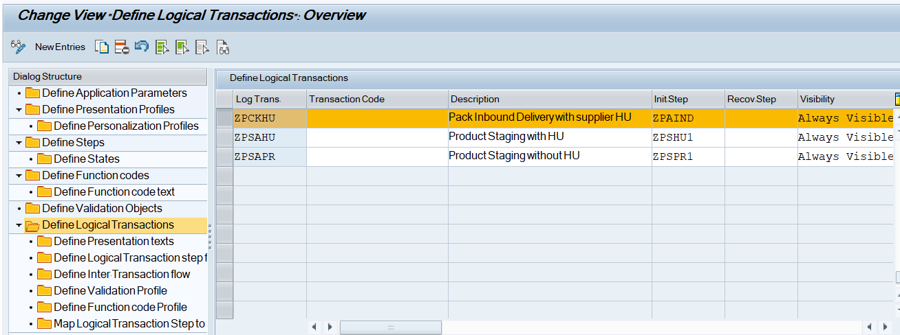

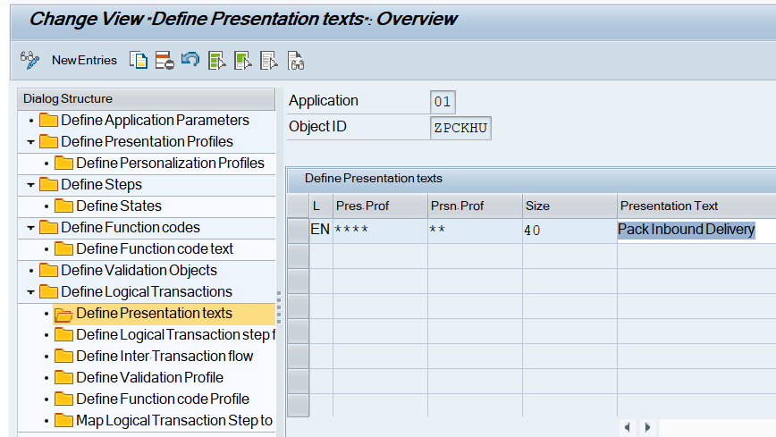

Logical Transaction step flow:

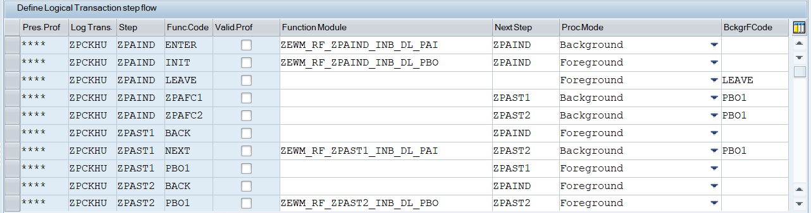

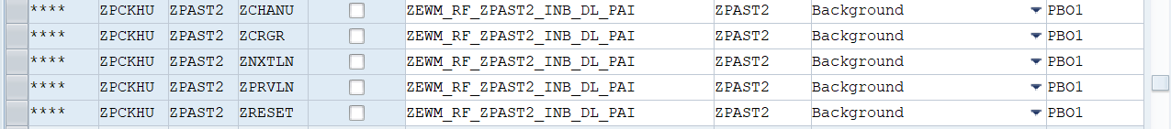

Define Function code Profile.

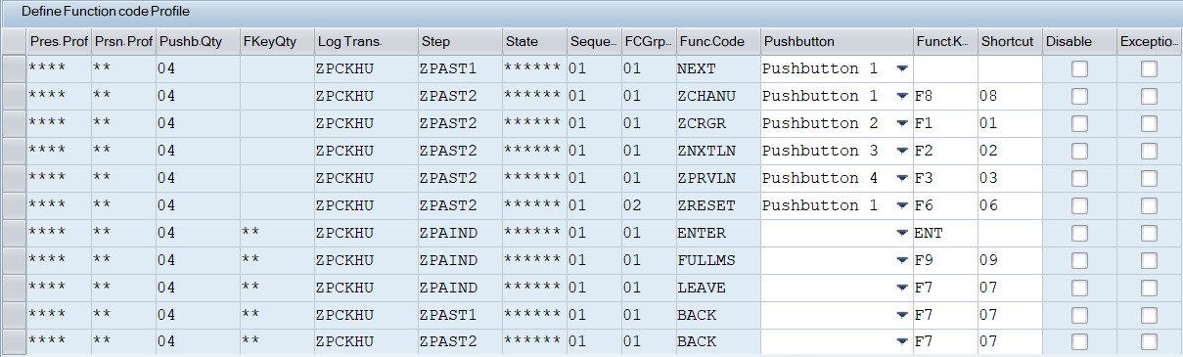



Map Logical Transaction Step to Sub-Screen

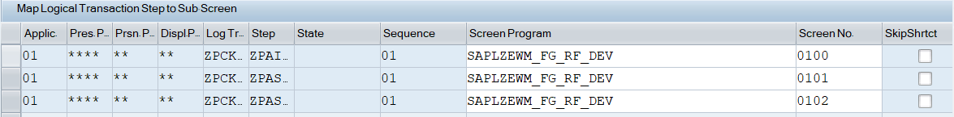

Define custom function codes.

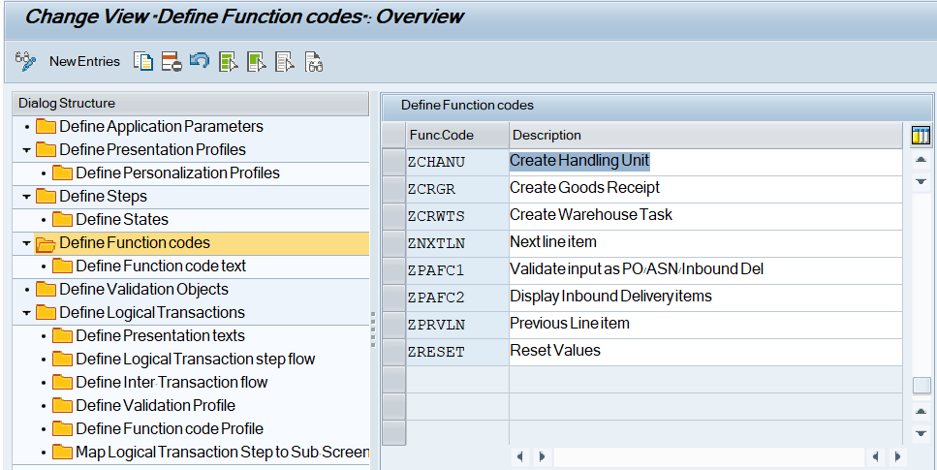

Define function code text for each custom function code as shown below:

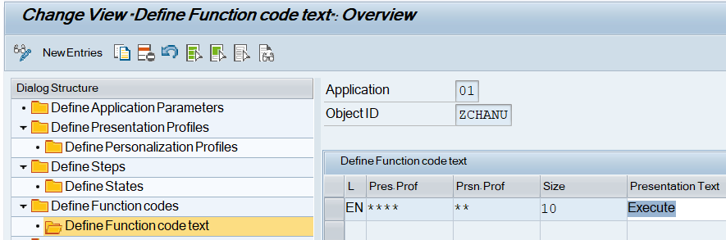

Define screen parameters structures.

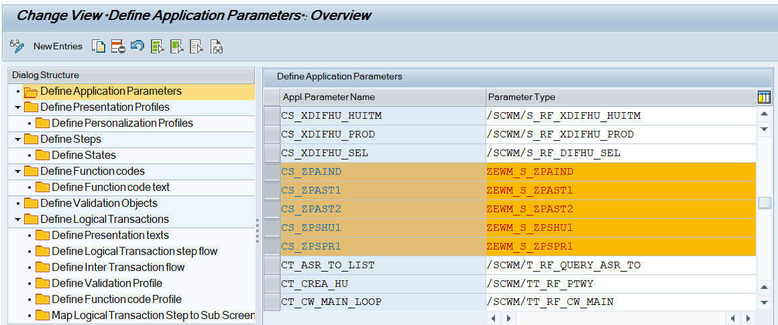

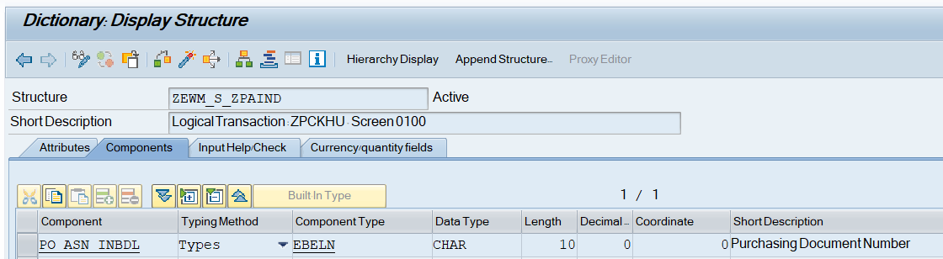

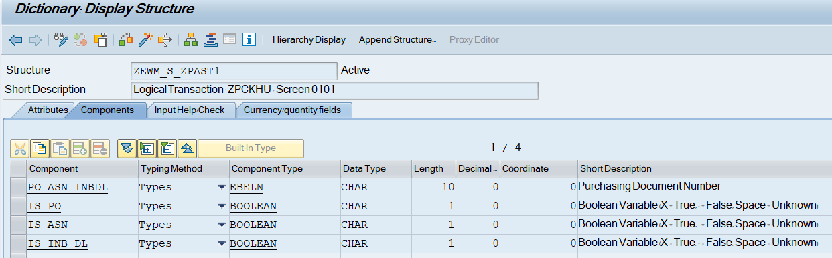

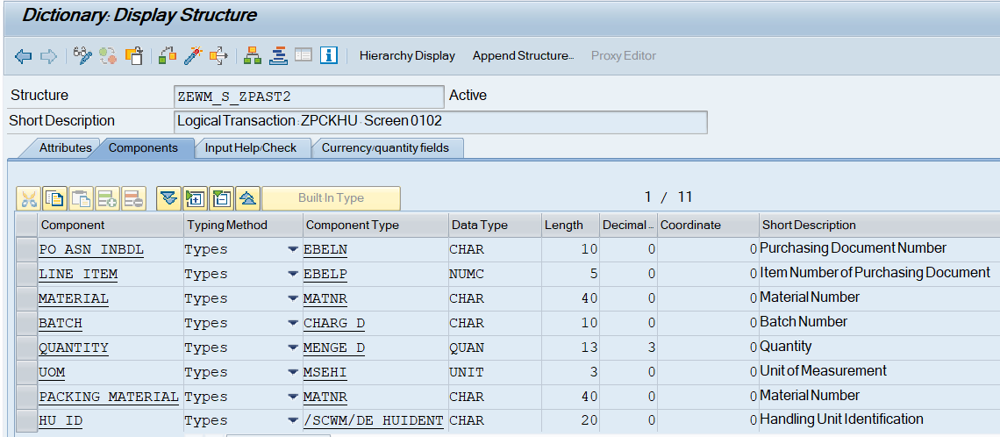



Technical configuration details of complete development:

Logical Transaction: ZPCKHU  Pack Inbound Delivery with supplier HU

Steps:

ZPAIND      Initial Step                   Screen: 0100     Screen Structure: ZEWM_S_ZPAIND

ZPAST1      Validate input as PO/ASN/Inb DL Screen: 0101     Screen Structure: ZEWM_S_ZPAST1

ZPAST2      Display Inbound Delivery items  Screen: 0102     Screen Structure: ZEWM_S_ZPAST2

FM:

ZEWM_RF_ZPAIND_INB_DL_PAI

ZEWM_RF_ZPAIND_INB_DL_PBO

ZEWM_RF_ZPAST1_INB_DL_PAI

ZEWM_RF_ZPAST2_INB_DL_PAI

-------------------------------------------------------------------------------------------------------------------------------------------

FUNCTION zewm_rf_zpaind_inb_dl_pbo.  
*"----------------------------------------------------------------------  
*"*"Local Interface:  
*"  CHANGING  
*"     REFERENCE(CS_ZPAIND) TYPE  ZEWM_S_ZPAIND  
*"     REFERENCE(CS_ZPAST1) TYPE  ZEWM_S_ZPAST1  
*"     REFERENCE(CS_ZPAST2) TYPE  ZEWM_S_ZPAST2  
*"----------------------------------------------------------------------  
  
  CLEAR:cs_zpaind,  
        cs_zpast1.  
  
*Set screen parameters  
  CALL METHOD /scwm/cl_rf_bll_srvc=>init_screen_param.  
  
  CALL METHOD /scwm/cl_rf_bll_srvc=>set_screen_param  
    EXPORTING  
      iv_param_name = gc_param_cs_zpaind.  
  
  CALL METHOD /scwm/cl_rf_bll_srvc=>set_screen_param  
    EXPORTING  
      iv_param_name = gc_param_cs_zpast1.  
  
  CALL METHOD /scwm/cl_rf_bll_srvc=>set_screen_param  
    EXPORTING  
      iv_param_name = gc_param_cs_zpast2.  
  
ENDFUNCTION.

 -------------------------------------------------------------------------------------------------------------------------------------------

 -------------------------------------------------------------------------------------------------------------------------------------------

FUNCTION zewm_rf_zpaind_inb_dl_pai.  
*"----------------------------------------------------------------------  
*"*"Local Interface:  
*"  CHANGING  
*"     REFERENCE(CS_ZPAIND) TYPE  ZEWM_S_ZPAIND  
*"     REFERENCE(CS_ZPAST1) TYPE  ZEWM_S_ZPAST1  
*"     REFERENCE(CS_ZPAST2) TYPE  ZEWM_S_ZPAST2  
*"----------------------------------------------------------------------  
  
  DATA:lv_inb_dl  TYPE /scdl/dl_docno_int,  
       lv_ibd_no  TYPE /scdl/dl_docno_int,  
       lv_counter TYPE i.  
  
  DATA:ls_huhdr TYPE /scwm/s_huhdr_int.  
  
  DATA:lt_huitm TYPE /scwm/tt_huitm_int,  
       lt_huref TYPE /scwm/tt_huref_int.  
  
  DATA:lo_packing TYPE REF TO /scwm/cl_wm_packing.  
  
  CLEAR gt_process_data.  
  
  IF cs_zpaind-po_asn_inbdl IS INITIAL.  
    MESSAGE e006(zewm01).  
  ENDIF.  
  
*Set values in the screen to be navigated  
  cs_zpast1-po_asn_inbdl = cs_zpaind-po_asn_inbdl.  
  cs_zpast2-po_asn_inbdl = cs_zpaind-po_asn_inbdl.  
  
*Check for input value as PO/ASN/Inbound Delivery  
  
  SELECT SINGLE @abap_true  
  FROM ekko  
  INTO @DATA(lv_exists)  
  WHERE ebeln EQ @cs_zpaind-po_asn_inbdl.  
  IF sy-subrc EQ 0.  
    DATA(lv_po) = abap_true.  
    lv_counter = 1.  
  ENDIF.  
  
  CLEAR lv_exists.  
  SELECT SINGLE @abap_true  
  FROM /scdl/db_proch_i  
  INTO @lv_exists  
  WHERE refdocno_extasn EQ @cs_zpaind-po_asn_inbdl.  
  IF sy-subrc EQ 0.  
    DATA(lv_asn) = abap_true.  
  
    IF lv_counter IS INITIAL.  
      lv_counter = 1.  
    ELSE.  
      lv_counter = lv_counter + 1.  
    ENDIF.  
  ENDIF.  
  
  lv_inb_dl = cs_zpaind-po_asn_inbdl.  
  CALL FUNCTION 'CONVERSION_EXIT_ALPHA_INPUT'  
    EXPORTING  
      input  = lv_inb_dl  
    IMPORTING  
      output = lv_inb_dl.  
  
  CLEAR lv_exists.  
  SELECT SINGLE @abap_true  
  FROM /scdl/db_proch_i  
  INTO @lv_exists  
  WHERE docno EQ @lv_inb_dl.  
  IF sy-subrc EQ 0.  
    DATA(lv_inb_delv) = abap_true.  
  
    IF lv_counter IS INITIAL.  
      lv_counter = 1.  
    ELSE.  
      lv_counter = lv_counter + 1.  
    ENDIF.  
  ENDIF.  
  
  IF lv_counter IS INITIAL.  
    MESSAGE e006(zewm01).  
  ELSE.  
    IF lv_counter GT 1.  
      /scwm/cl_rf_bll_srvc=>set_prmod( EXPORTING iv_prmod = '1' ).  
      /scwm/cl_rf_bll_srvc=>set_fcode( EXPORTING iv_fcode = gc_scr_fcode_zpafc1 ).  
    ELSE.  
  
*-------------------------------------------------------------------------------------  
*Get data for processing against a PO  
*-------------------------------------------------------------------------------------  
      IF lv_po EQ abap_true.  
  
*Validate if multiple inbound deliveries exists for a PO  
        SELECT DISTINCT COUNT( docno )  
        FROM /scdl/db_proci_i  
        WHERE refdocno_po EQ @cs_zpaind-po_asn_inbdl  
        INTO @DATA(lv_total_inb_delv).  
        IF sy-subrc EQ 0 AND  
           lv_total_inb_delv GT 1.  
          MESSAGE e008(zewm01).  
        ENDIF.  
  
        SELECT docid,  
               docno,  
               itemid,  
               itemno,  
               productno,  
               productid,  
               batchno,  
               qty,  
               uom,  
               refdocno_po,  
               /scwm/whno  
        FROM /scdl/db_proci_i  
        WHERE refdocno_po EQ @cs_zpaind-po_asn_inbdl  
        INTO CORRESPONDING FIELDS OF TABLE @gt_process_data.  
        IF sy-subrc NE 0.  
          MESSAGE e012(zewm01) WITH cs_zpaind-po_asn_inbdl.  
        ENDIF.  
      ENDIF.  
*-------------------------------------------------------------------------------------  
  
*-------------------------------------------------------------------------------------  
*Get data for processing against a ASN  
*-------------------------------------------------------------------------------------  
      IF lv_asn EQ abap_true.  
  
*Validate if multiple inbound deliveries exists for a ASN  
        SELECT DISTINCT COUNT( docno )  
        FROM /scdl/db_proch_i  
        WHERE refdocno_extasn EQ @cs_zpaind-po_asn_inbdl  
        INTO @lv_total_inb_delv.  
        IF sy-subrc EQ 0 AND  
           lv_total_inb_delv GT 1.  
          MESSAGE e009(zewm01).  
        ENDIF.  
  
        SELECT a~docid,  
               a~docno,  
               b~itemid,  
               b~itemno,  
               b~productno,  
               b~productid,  
               b~batchno,  
               b~qty,  
               b~uom,  
               a~refdocno_extasn,  
               b~/scwm/whno  
         FROM /scdl/db_proch_i AS a INNER JOIN /scdl/db_proci_i AS b ON b~docid EQ a~docid AND  
                                                                        b~docno EQ a~docno  
         WHERE a~refdocno_extasn EQ @cs_zpaind-po_asn_inbdl  
         INTO CORRESPONDING FIELDS OF TABLE @gt_process_data.  
        IF sy-subrc NE 0.  
          MESSAGE e012(zewm01) WITH cs_zpaind-po_asn_inbdl.  
        ENDIF.  
      ENDIF.  
*-------------------------------------------------------------------------------------  
  
*-------------------------------------------------------------------------------------  
*Get data for processing against a Inbound Delivery  
*-------------------------------------------------------------------------------------  
      IF lv_inb_delv EQ abap_true.  
  
        SELECT docid,  
               docno,  
               itemid,  
               itemno,  
               productno,  
               productid,  
               batchno,  
               qty,  
               uom,  
               /scwm/whno  
        FROM /scdl/db_proci_i  
        WHERE docno EQ @lv_inb_dl  
        INTO CORRESPONDING FIELDS OF TABLE @gt_process_data.  
        IF sy-subrc NE 0.  
          MESSAGE e012(zewm01) WITH cs_zpaind-po_asn_inbdl.  
        ENDIF.  
      ENDIF.  
*-------------------------------------------------------------------------------------  
  
*-------------------------------------------------------------------------------------  
*Exclude the line items for which the GR is already done  
*-------------------------------------------------------------------------------------  
      IF gt_process_data IS NOT INITIAL.  
        SELECT docid,  
               itemid,  
               status_type,  
               status_value  
        FROM /scdl/db_status  
        FOR ALL ENTRIES IN @gt_process_data  
        WHERE docid        EQ @gt_process_data-docid  AND  
              itemid       EQ @gt_process_data-itemid AND  
              status_type  EQ 'DGR'                  AND  
              status_value EQ '9'  
        INTO TABLE @DATA(lt_status).  
        IF sy-subrc EQ 0.  
          LOOP AT lt_status ASSIGNING FIELD-SYMBOL(<lfs_status>).  
            DELETE gt_process_data WHERE docid  EQ <lfs_status>-docid AND  
                                         itemid EQ <lfs_status>-itemid.  
          ENDLOOP.  
        ENDIF.  
      ENDIF.  
  
*-------------------------------------------------------------------------------------  
*Reduce the quantity already packed from quantity to be packed.  
*-------------------------------------------------------------------------------------  
      IF lo_packing IS NOT BOUND.  
        lo_packing = NEW #( ).  
      ENDIF.  
  
      IF gt_process_data IS NOT INITIAL.  
        SELECT a~docid,  
               a~itemid,  
               b~guid_parent,  
               b~qdocid,  
               b~qitmid,  
               c~guid_hu,  
               c~huident  
        FROM /scdl/db_proci_i AS a INNER JOIN /scwm/quan AS b ON b~qdocid  EQ a~docid  AND  
                                                                 b~qitmid  EQ a~itemid AND  
                                                                 b~qdoccat EQ 'PDI'  
                                   INNER JOIN /scwm/huhdr AS c ON c~guid_hu EQ b~guid_parent  
        FOR ALL ENTRIES IN @gt_process_data  
        WHERE a~docno  EQ @gt_process_data-docno  AND  
              a~itemno EQ @gt_process_data-itemno  
        INTO TABLE @DATA(lt_hu_data).  
        IF sy-subrc EQ 0.  
          SORT lt_hu_data BY docid itemid guid_hu huident.  
  
          LOOP AT lt_hu_data ASSIGNING FIELD-SYMBOL(<lfs_hu_data>).  
  
            CLEAR:ls_huhdr,  
                  lt_huitm,  
                  lt_huref.  
  
            CALL METHOD lo_packing->get_hu  
              EXPORTING  
                iv_huident = <lfs_hu_data>-huident  
              IMPORTING  
                es_huhdr   = ls_huhdr  
                et_huitm   = lt_huitm  
                et_huref   = lt_huref  
              EXCEPTIONS  
                not_found  = 1  
                OTHERS     = 2.  
            IF sy-subrc <> 0.  
              MESSAGE ID sy-msgid TYPE sy-msgty NUMBER sy-msgno WITH sy-msgv1 sy-msgv2 sy-msgv3 sy-msgv4.  
            ENDIF.  
  
            LOOP AT lt_huitm ASSIGNING FIELD-SYMBOL(<lfs_huitm>).  
              READ TABLE gt_process_data ASSIGNING FIELD-SYMBOL(<lfs_process_data>)  
                  WITH KEY docid  = <lfs_hu_data>-docid  
                           itemid = <lfs_hu_data>-itemid.  
              IF sy-subrc EQ 0.  
                <lfs_process_data>-qty = <lfs_process_data>-qty - <lfs_huitm>-quan.  
              ENDIF.  
            ENDLOOP.  
  
          ENDLOOP.  
        ENDIF.  
      ENDIF.  
  
*-------------------------------------------------------------------------------------  
*Map data to the screen structure  
*-------------------------------------------------------------------------------------  
      SORT gt_process_data BY itemno.  
      DATA(ls_process_data) = gt_process_data[ 1 ].  
  
      CLEAR lv_ibd_no.  
      lv_ibd_no = ls_process_data-docno.  
      CALL FUNCTION 'CONVERSION_EXIT_ALPHA_OUTPUT'  
        EXPORTING  
          input  = lv_ibd_no  
        IMPORTING  
          output = lv_ibd_no.  
  
      cs_zpast2-po_asn_inbdl = lv_ibd_no.  
      cs_zpast2-line_item    = ls_process_data-itemno.  
      cs_zpast2-material     = ls_process_data-productno.  
      cs_zpast2-batch        = ls_process_data-batchno.  
      cs_zpast2-quantity     = ls_process_data-qty.  
      cs_zpast2-uom          = ls_process_data-uom.  
  
*-------------------------------------------------------------------------------------  
*Get packing material for the warehouse  
*-------------------------------------------------------------------------------------  
      IF gt_process_data IS NOT INITIAL.  
        DATA(lv_warehouseno) = gt_process_data[ 1 ]-/scwm/whno.  
      ENDIF.  
  
      IF lv_warehouseno IS NOT INITIAL.  
        SELECT SINGLE packing_material  
        FROM zewm_t_mat_conf  
        WHERE warehouse_no EQ @lv_warehouseno  
        INTO @DATA(lv_packing_material).  
        IF sy-subrc EQ 0.  
          cs_zpast2-packing_material = lv_packing_material.  
        ENDIF.  
      ENDIF.  
*-------------------------------------------------------------------------------------  
  
      /scwm/cl_rf_bll_srvc=>set_lgnum( iv_lgnum = lv_warehouseno ).  
      /scwm/cl_rf_bll_srvc=>set_prmod( EXPORTING iv_prmod = '1' ).  
      /scwm/cl_rf_bll_srvc=>set_fcode( EXPORTING iv_fcode = gc_scr_fcode_zpafc2 ).  
  
    ENDIF.  
  ENDIF.  
  
ENDFUNCTION.

-------------------------------------------------------------------------------------------------------------------------------------------

-------------------------------------------------------------------------------------------------------------------------------------------

FUNCTION zewm_rf_zpast1_inb_dl_pai.  
*"----------------------------------------------------------------------  
*"*"Local Interface:  
*"  CHANGING  
*"     REFERENCE(CS_ZPAIND) TYPE  ZEWM_S_ZPAIND  
*"     REFERENCE(CS_ZPAST1) TYPE  ZEWM_S_ZPAST1  
*"     REFERENCE(CS_ZPAST2) TYPE  ZEWM_S_ZPAST2  
*"----------------------------------------------------------------------  
  
  DATA:lo_packing TYPE REF TO /scwm/cl_wm_packing.  
  
  DATA:lv_ibd_no TYPE /scdl/dl_docno_int.  
  
  DATA:ls_huhdr TYPE /scwm/s_huhdr_int.  
  
  DATA:lt_huitm TYPE /scwm/tt_huitm_int,  
       lt_huref TYPE /scwm/tt_huref_int.  
  
  DATA(lv_fcode) = /scwm/cl_rf_bll_srvc=>get_fcode( ).  
  
  IF lv_fcode EQ 'NEXT'.  
  
*-------------------------------------------------------------------------------------  
*Get data for processing against a PO  
*-------------------------------------------------------------------------------------  
    IF cs_zpast1-is_po EQ abap_true.  
  
*Validate if multiple inbound deliveries exists for a PO  
      SELECT DISTINCT COUNT( docno )  
      FROM /scdl/db_proci_i  
      WHERE refdocno_po EQ @cs_zpast1-po_asn_inbdl  
      INTO @DATA(lv_total_inb_delv).  
      IF sy-subrc EQ 0 AND  
         lv_total_inb_delv GT 1.  
        MESSAGE e008(zewm01).  
      ENDIF.  
  
      SELECT docid,  
             docno,  
             itemid,  
             itemno,  
             productno,  
             productid,  
             batchno,  
             qty,  
             uom,  
             refdocno_po,  
             /scwm/whno  
      FROM /scdl/db_proci_i  
      WHERE refdocno_po EQ @cs_zpast1-po_asn_inbdl  
      INTO CORRESPONDING FIELDS OF TABLE @gt_process_data.  
      IF sy-subrc NE 0.  
        MESSAGE e012(zewm01) WITH cs_zpast1-po_asn_inbdl.  
      ENDIF.  
    ENDIF.  
*-------------------------------------------------------------------------------------  
  
*-------------------------------------------------------------------------------------  
*Get data for processing against a ASN  
*-------------------------------------------------------------------------------------  
    IF cs_zpast1-is_asn EQ abap_true.  
  
*Validate if multiple inbound deliveries exists for a ASN  
      SELECT DISTINCT COUNT( docno )  
      FROM /scdl/db_proch_i  
      WHERE refdocno_extasn EQ @cs_zpast1-po_asn_inbdl  
      INTO @lv_total_inb_delv.  
      IF sy-subrc EQ 0 AND  
         lv_total_inb_delv GT 1.  
        MESSAGE e009(zewm01).  
      ENDIF.  
  
      SELECT a~docid,  
             a~docno,  
             b~itemid,  
             b~itemno,  
             b~productno,  
             b~productid,  
             b~batchno,  
             b~qty,  
             b~uom,  
             a~refdocno_extasn,  
             b~/scwm/whno  
       FROM /scdl/db_proch_i AS a INNER JOIN /scdl/db_proci_i AS b ON b~docid EQ a~docid AND  
                                                                      b~docno EQ a~docno  
       WHERE a~refdocno_extasn EQ @cs_zpast1-po_asn_inbdl  
       INTO CORRESPONDING FIELDS OF TABLE @gt_process_data.  
      IF sy-subrc NE 0.  
        MESSAGE e012(zewm01) WITH cs_zpast1-po_asn_inbdl.  
      ENDIF.  
  
    ENDIF.  
*-------------------------------------------------------------------------------------  
  
*-------------------------------------------------------------------------------------  
*Get data for processing against a Inbound Delivery  
*-------------------------------------------------------------------------------------  
    IF cs_zpast1-is_inb_dl EQ abap_true.  
  
      SELECT docid,  
             docno,  
             itemid,  
             itemno,  
             productno,  
             productid,  
             batchno,  
             qty,  
             uom,  
             /scwm/whno  
      FROM /scdl/db_proci_i  
      WHERE docno EQ @cs_zpast1-po_asn_inbdl  
      INTO CORRESPONDING FIELDS OF TABLE @gt_process_data.  
      IF sy-subrc NE 0.  
        MESSAGE e011(zewm01) WITH cs_zpast1-po_asn_inbdl.  
      ENDIF.  
  
    ENDIF.  
*-------------------------------------------------------------------------------------  
  
*-------------------------------------------------------------------------------------  
*Exclude the line items for which the GR is already done  
*-------------------------------------------------------------------------------------  
    IF gt_process_data IS NOT INITIAL.  
      SELECT docid,  
             itemid,  
             status_type,  
             status_value  
      FROM /scdl/db_status  
      FOR ALL ENTRIES IN @gt_process_data  
      WHERE docid        EQ @gt_process_data-docid  AND  
            itemid       EQ @gt_process_data-itemid AND  
            status_type  EQ 'DGR'                  AND  
            status_value EQ '9'  
      INTO TABLE @DATA(lt_status).  
      IF sy-subrc EQ 0.  
        LOOP AT lt_status ASSIGNING FIELD-SYMBOL(<lfs_status>).  
          DELETE gt_process_data WHERE docid  EQ <lfs_status>-docid AND  
                                       itemid EQ <lfs_status>-itemid.  
        ENDLOOP.  
      ENDIF.  
    ENDIF.  
  
*-------------------------------------------------------------------------------------  
*Reduce the quantity already packed from quantity to be packed.  
*-------------------------------------------------------------------------------------  
    IF lo_packing IS NOT BOUND.  
      lo_packing = NEW #( ).  
    ENDIF.  
  
    IF gt_process_data IS NOT INITIAL.  
      SELECT a~docid,  
             a~itemid,  
             b~guid_parent,  
             b~qdocid,  
             b~qitmid,  
             c~guid_hu,  
             c~huident  
      FROM /scdl/db_proci_i AS a INNER JOIN /scwm/quan AS b ON b~qdocid  EQ a~docid  AND  
                                                               b~qitmid  EQ a~itemid AND  
                                                               b~qdoccat EQ 'PDI'  
                                 INNER JOIN /scwm/huhdr AS c ON c~guid_hu EQ b~guid_parent  
      FOR ALL ENTRIES IN @gt_process_data  
      WHERE a~docno  EQ @gt_process_data-docno  AND  
            a~itemno EQ @gt_process_data-itemno  
      INTO TABLE @DATA(lt_hu_data).  
      IF sy-subrc EQ 0.  
        SORT lt_hu_data BY docid itemid guid_hu huident.  
  
        LOOP AT lt_hu_data ASSIGNING FIELD-SYMBOL(<lfs_hu_data>).  
  
          CLEAR:ls_huhdr,  
                lt_huitm,  
                lt_huref.  
  
          CALL METHOD lo_packing->get_hu  
            EXPORTING  
              iv_huident = <lfs_hu_data>-huident  
            IMPORTING  
              es_huhdr   = ls_huhdr  
              et_huitm   = lt_huitm  
              et_huref   = lt_huref  
            EXCEPTIONS  
              not_found  = 1  
              OTHERS     = 2.  
          IF sy-subrc <> 0.  
            MESSAGE ID sy-msgid TYPE sy-msgty NUMBER sy-msgno WITH sy-msgv1 sy-msgv2 sy-msgv3 sy-msgv4.  
          ENDIF.  
  
          LOOP AT lt_huitm ASSIGNING FIELD-SYMBOL(<lfs_huitm>).  
            READ TABLE gt_process_data ASSIGNING FIELD-SYMBOL(<lfs_process_data>)  
                WITH KEY docid  = <lfs_hu_data>-docid  
                         itemid = <lfs_hu_data>-itemid.  
            IF sy-subrc EQ 0.  
              <lfs_process_data>-qty = <lfs_process_data>-qty - <lfs_huitm>-quan.  
            ENDIF.  
          ENDLOOP.  
  
        ENDLOOP.  
      ENDIF.  
    ENDIF.  
  
*-------------------------------------------------------------------------------------  
*Map data to the screen structure  
*-------------------------------------------------------------------------------------  
    SORT gt_process_data BY itemno.  
    DATA(ls_process_data) = gt_process_data[ 1 ].  
  
    CLEAR lv_ibd_no.  
    lv_ibd_no = ls_process_data-docno.  
    CALL FUNCTION 'CONVERSION_EXIT_ALPHA_OUTPUT'  
      EXPORTING  
        input  = lv_ibd_no  
      IMPORTING  
        output = lv_ibd_no.  
  
    cs_zpast2-po_asn_inbdl = lv_ibd_no.  
    cs_zpast2-line_item    = ls_process_data-itemno.  
    cs_zpast2-material     = ls_process_data-productno.  
    cs_zpast2-batch        = ls_process_data-batchno.  
    cs_zpast2-quantity     = ls_process_data-qty.  
    cs_zpast2-uom          = ls_process_data-uom.  
  
*-------------------------------------------------------------------------------------  
*Get packing material for the warehouse  
*-------------------------------------------------------------------------------------  
  
    DATA(lv_warehouseno) = /scwm/cl_rf_bll_srvc=>get_lgnum( ).  
  
    IF lv_warehouseno IS NOT INITIAL.  
      SELECT SINGLE packing_material  
      FROM zewm_t_mat_conf  
      WHERE warehouse_no EQ @lv_warehouseno  
      INTO @DATA(lv_packing_material).  
      IF sy-subrc EQ 0.  
        cs_zpast2-packing_material = lv_packing_material.  
      ENDIF.  
    ENDIF.  
*-------------------------------------------------------------------------------------  
  
  ENDIF.  
  
ENDFUNCTION.

-------------------------------------------------------------------------------------------------------------------------------------------

-------------------------------------------------------------------------------------------------------------------------------------------

FUNCTION zewm_rf_zpast2_inb_dl_pai.  
*"----------------------------------------------------------------------  
*"*"Local Interface:  
*"  CHANGING  
*"     REFERENCE(CS_ZPAIND) TYPE  ZEWM_S_ZPAIND  
*"     REFERENCE(CS_ZPAST1) TYPE  ZEWM_S_ZPAST1  
*"     REFERENCE(CS_ZPAST2) TYPE  ZEWM_S_ZPAST2  
*"----------------------------------------------------------------------  
  
  DATA(lv_fcode) = /scwm/cl_rf_bll_srvc=>get_fcode( ).  
  
  CLEAR cs_zpast2-gr_status.  
  
  CASE lv_fcode.  
    WHEN 'ZCHANU'.  
  
      IF cs_zpast2-quantity IS INITIAL.  
        MESSAGE e010(zewm01).  
      ENDIF.  
  
      CALL FUNCTION 'ZEWM_RF_CREATE_AND_PACK_HU'  
        CHANGING  
          cs_zpast2 = cs_zpast2.  
  
    WHEN 'ZCRGR'.  
  
      CALL FUNCTION 'ZEWM_RF_POST_GOODS_RECEIPT'  
        CHANGING  
          cs_zpast2 = cs_zpast2.  
  
      CALL FUNCTION 'ZEWM_RF_CRT_AND_CONF_TASK'  
        CHANGING  
          cs_zpast2 = cs_zpast2.  
  
      cs_zpast2-gr_status = abap_true.  
  
    WHEN 'ZNXTLN'.  
      IF gt_process_data IS NOT INITIAL.  
        DATA(lv_index) = line_index( gt_process_data[ itemno = cs_zpast2-line_item ] ).  
  
        IF line_exists( gt_process_data[ lv_index + 1 ] ).  
          DATA(ls_process_data) = gt_process_data[ lv_index + 1 ].  
          CLEAR cs_zpast2-hu_pack_counter.  
        ELSE.  
          ls_process_data = gt_process_data[ lv_index ].  
        ENDIF.  
  
        cs_zpast2-line_item = ls_process_data-itemno.  
        cs_zpast2-material  = ls_process_data-productno.  
        cs_zpast2-batch     = ls_process_data-batchno.  
        cs_zpast2-quantity  = ls_process_data-qty - ls_process_data-qty_packed.  
        cs_zpast2-uom       = ls_process_data-uom.  
  
      ENDIF.  
    WHEN 'ZPRVLN'.  
      IF gt_process_data IS NOT INITIAL.  
        lv_index = line_index( gt_process_data[ itemno = cs_zpast2-line_item ] ).  
  
        IF line_exists( gt_process_data[ lv_index - 1 ] ).  
          ls_process_data = gt_process_data[ lv_index - 1 ].  
        ELSE.  
          ls_process_data = gt_process_data[ lv_index ].  
        ENDIF.  
  
        cs_zpast2-line_item = ls_process_data-itemno.  
        cs_zpast2-material  = ls_process_data-productno.  
        cs_zpast2-batch     = ls_process_data-batchno.  
        cs_zpast2-quantity  = ls_process_data-qty - ls_process_data-qty_packed.  
        cs_zpast2-uom       = ls_process_data-uom.  
      ENDIF.  
  
    WHEN 'ZRESET'.  
      CLEAR cs_zpast2-hu_id.  
  
    WHEN OTHERS.  
  ENDCASE.  
  
ENDFUNCTION.

-------------------------------------------------------------------------------------------------------------------------------------------

-------------------------------------------------------------------------------------------------------------------------------------------

CALL FUNCTION 'ZEWM_RF_CREATE_AND_PACK_HU'  
        CHANGING  
          cs_zpast2 = cs_zpast2.

FUNCTION zewm_rf_create_and_pack_hu.  
*"----------------------------------------------------------------------  
*"*"Local Interface:  
*"  CHANGING  
*"     REFERENCE(CS_ZPAST2) TYPE  ZEWM_S_ZPAST2  
*"----------------------------------------------------------------------  
  
  DATA:lv_inb_dl     TYPE /scdl/dl_docno_int,  
       lv_rejected   TYPE boole_d,  
       lv_severity   TYPE bapi_mtype,  
       lv_matid_guid TYPE /scwm/de_matid.  
  
  DATA:lo_pack     TYPE REF TO /scwm/cl_dlv_pack_ibdl,  
       lo_message  TYPE REF TO /scdl/cl_dm_message,  
       lo_dlv_save TYPE REF TO /scwm/cl_dlv_management_prd,  
       lo_packing  TYPE REF TO /scwm/cl_wm_packing.  
  
  DATA:ls_levels         TYPE /scwm/s_ps_level_int,  
       ls_hu_create      TYPE /scwm/s_huhdr_create_ext,  
       ls_huhdr          TYPE /scwm/s_huhdr_int,  
       ls_psp_hdr        TYPE /scwm/s_ps_header_int,  
       ls_packspec_level TYPE /scwm/s_ps_level_int,  
       ls_psp_content    TYPE /scwm/s_packspec_nested,  
       ls_material       TYPE /scwm/s_pack_stock,  
       ls_quantity       TYPE /scwm/s_quan,  
       ls_hu_ident       TYPE /scwm/hu_ident.  
  
  DATA:lt_hu           TYPE /scwm/t_gm_hu,  
       lt_docid        TYPE /scwm/tt_docid,  
       lt_psp_content  TYPE /scwm/tt_packspec_nested,  
       lt_elementgroup TYPE /scwm/tt_ps_elementgroup,  
       lt_message      TYPE /scdl/dm_message_tab,  
       lt_crea_hu      TYPE /scwm/tt_to_prep_hu_int.  
  
  DATA(ls_process) = gt_process_data[ itemno = cs_zpast2-line_item ].  
  
*------------------------------------------------------------------------------------------------------  
*Fill packaging specification relevant info in case it is present for material.  
*------------------------------------------------------------------------------------------------------  
  IF ls_process-productid IS NOT INITIAL.  
    CALL FUNCTION '/SCWM/PS_PACKSPEC_GET'  
      EXPORTING  
        iv_guid_ps          = ls_process-productid  
        iv_read_elements    = 'X'  
      IMPORTING  
        es_packspec_header  = ls_psp_hdr  
        et_packspec_content = lt_psp_content  
        et_elementgroup     = lt_elementgroup  
        es_packspec_level   = ls_packspec_level  
      EXCEPTIONS  
        error               = 1  
        OTHERS              = 2.  
    IF sy-subrc <> 0.  
    ENDIF.  
  
    IF lt_psp_content IS NOT INITIAL.  
      ls_psp_content = lt_psp_content[ 1 ].  
  
      IF line_exists( ls_psp_content-levels[ hu_create = abap_true ] ).  
        ls_levels = ls_psp_content-levels[ hu_create = abap_true ].  
  
        ls_hu_create-tare_var       = ls_levels-tare_var.  
        ls_hu_create-closed_package = ls_levels-closed_package.  
  
        IF ls_levels-flag_weight EQ abap_true.  
          ls_hu_create-unit_gw  = ls_levels-unit_gw.  
          ls_hu_create-t_weight = ls_levels-t_weight.  
          ls_hu_create-unit_tw  = ls_levels-unit_tw.  
        ENDIF.  
  
        IF ls_levels-flag_vol EQ abap_true.  
          ls_hu_create-unit_gv  = ls_levels-unit_gv.  
          ls_hu_create-t_volume = ls_levels-t_volume.  
          ls_hu_create-unit_tv  = ls_levels-unit_tv.  
        ENDIF.  
  
        IF ls_levels-flag_dim EQ abap_true.  
          ls_hu_create-length       = ls_levels-length.  
          ls_hu_create-width        = ls_levels-width.  
          ls_hu_create-height       = ls_levels-height.  
          ls_hu_create-unit_lwh     = ls_levels-unit_lwh.  
          ls_hu_create-max_length   = ls_levels-max_length.  
          ls_hu_create-max_width    = ls_levels-max_width.  
          ls_hu_create-max_height   = ls_levels-max_height.  
          ls_hu_create-unit_max_lwh = ls_levels-unit_max_lwh.  
        ENDIF.  
  
        IF ls_levels-flag_capa EQ abap_true.  
          ls_hu_create-t_capa   = ls_levels-t_capa.  
          ls_hu_create-max_capa = ls_levels-max_capa.  
          ls_hu_create-tolc     = ls_levels-tolc.  
        ENDIF.  
  
      ENDIF.  
    ENDIF.  
  
  ENDIF.  
*------------------------------------------------------------------------------------------------------  
  
*------------------------------------------------------------------------------------------------------  
*Create Handling Unit  
*------------------------------------------------------------------------------------------------------  
  IF lo_pack IS NOT BOUND.  
    lo_pack = NEW #( ).  
  ENDIF.  
  
*Get packing material guid  
  IF cs_zpast2-packing_material IS NOT INITIAL.  
  
    CLEAR lv_matid_guid.  
    CALL FUNCTION '/SCWM/WC_GET_MATID'  
      EXPORTING  
        iv_id    = cs_zpast2-packing_material  
      IMPORTING  
        ev_matid = lv_matid_guid  
      EXCEPTIONS  
        error    = 1  
        OTHERS   = 2.  
    IF sy-subrc <> 0.  
      MESSAGE ID sy-msgid TYPE sy-msgty NUMBER sy-msgno WITH sy-msgv1 sy-msgv2 sy-msgv3 sy-msgv4.  
    ENDIF.  
  
*Set warehouse number  
    lo_pack->gv_lgnum = /scwm/cl_rf_bll_srvc=>get_lgnum( ).  
  
*Initialize By Delivery  
    lt_docid = VALUE #( ( docid = ls_process-docid ) ).  
  
    lo_pack->init(  
      EXPORTING  
        iv_lgnum = /scwm/cl_rf_bll_srvc=>get_lgnum( )  
        it_docid = lt_docid ).  
  
    ls_hu_create-hutyp = 'E1'.  
  
    CALL METHOD lo_pack->/scwm/if_pack_bas~create_hu  
      EXPORTING  
        iv_pmat      = lv_matid_guid  
        is_hu_create = ls_hu_create  
      RECEIVING  
        es_huhdr     = ls_huhdr  
      EXCEPTIONS  
        error        = 1  
        OTHERS       = 2.  
    IF sy-subrc <> 0.  
      MESSAGE ID sy-msgid TYPE sy-msgty NUMBER sy-msgno WITH sy-msgv1 sy-msgv2 sy-msgv3 sy-msgv4.  
    ENDIF.  
  
*Update supplier provided HU  
    ls_hu_ident = VALUE #( mandt   = sy-mandt  
                           guid_hu = ls_huhdr-guid_hu  
                           idart   = 'E'  
                           huident = cs_zpast2-hu_id  ).  
  
    INSERT INTO /scwm/hu_ident VALUES ls_hu_ident.  
  
*Read created handling unit to populate its GUID in buffer  
    CALL FUNCTION '/SCWM/HUHEADER_READ'  
      EXPORTING  
        iv_guid_hu   = ls_huhdr-guid_hu  
        iv_huident   = ls_huhdr-huident  
        iv_db_select = 'A'  
        iv_lock      = 'X'  
      EXCEPTIONS  
        not_found    = 1  
        input        = 2  
        error        = 3  
        deleted      = 4  
        OTHERS       = 5.  
    IF sy-subrc <> 0.  
      MESSAGE ID sy-msgid TYPE sy-msgty NUMBER sy-msgno WITH sy-msgv1 sy-msgv2 sy-msgv3 sy-msgv4.  
    ENDIF.  
  
*------------------------------------------------------------------------------------------------------  
  
*------------------------------------------------------------------------------------------------------  
*Pack the stock to the empty HU  
*------------------------------------------------------------------------------------------------------  
    ls_material-qdoccat = 'PDI'.  
    ls_material-qdocid  = ls_process-docid.  
    ls_material-qitmid  = ls_process-itemid.  
    ls_quantity-quan    = cs_zpast2-quantity.  
    ls_quantity-unit    = cs_zpast2-uom.  
  
    CALL METHOD lo_pack->/scwm/if_pack_bas~pack_stock  
      EXPORTING  
        iv_dest_hu  = ls_huhdr-guid_hu  
        is_material = ls_material  
        is_quantity = ls_quantity  
      EXCEPTIONS  
        error       = 1  
        OTHERS      = 2.  
    IF sy-subrc <> 0.  
      MESSAGE ID sy-msgid TYPE sy-msgty NUMBER sy-msgno WITH sy-msgv1 sy-msgv2 sy-msgv3 sy-msgv4.  
    ENDIF.  
  
*------------------------------------------------------------------------------------------------------  
*Reduce the packed quantity from the quantity to be packed  
*------------------------------------------------------------------------------------------------------  
    READ TABLE gt_process_data ASSIGNING FIELD-SYMBOL(<lfs_process_data>)  
    WITH KEY itemno = cs_zpast2-line_item.  
    IF <lfs_process_data> IS ASSIGNED.  
      <lfs_process_data>-qty_packed = <lfs_process_data>-qty_packed + cs_zpast2-quantity.  
      cs_zpast2-quantity = <lfs_process_data>-qty - <lfs_process_data>-qty_packed.  
    ENDIF.  
  
*Update HU packing counter  
    cs_zpast2-hu_pack_counter = cs_zpast2-hu_pack_counter + 1.  
  
    CLEAR cs_zpast2-hu_id.  
  
    lo_pack->save(  
      EXPORTING  
        iv_commit = 'X'  
        iv_wait   = 'X'  
      EXCEPTIONS  
        error     = 1  
        OTHERS    = 2  
    ).  
    IF sy-subrc <> 0.  
      MESSAGE ID sy-msgid TYPE sy-msgty NUMBER sy-msgno WITH sy-msgv1 sy-msgv2 sy-msgv3 sy-msgv4.  
    ENDIF.  
  
  ENDIF.  
*------------------------------------------------------------------------------------------------------  
  
ENDFUNCTION.

-------------------------------------------------------------------------------------------------------------------------------------------

-------------------------------------------------------------------------------------------------------------------------------------------

CALL FUNCTION 'ZEWM_RF_POST_GOODS_RECEIPT'  
        CHANGING  
          cs_zpast2 = cs_zpast2.

FUNCTION zewm_rf_post_goods_receipt.  
*"----------------------------------------------------------------------  
*"*"Local Interface:  
*"  CHANGING  
*"     REFERENCE(CS_ZPAST2) TYPE  ZEWM_S_ZPAST2  
*"----------------------------------------------------------------------  
  
  DATA:lv_inb_dl   TYPE /scdl/dl_docno_int,  
       lv_rejected TYPE boole_d.  
  
  DATA: ls_huhdr TYPE /scwm/s_huhdr_int.  
  
  DATA:lt_hu      TYPE /scwm/t_gm_hu,  
       lt_message TYPE /scdl/dm_message_tab,  
       lt_huitm   TYPE /scwm/tt_huitm_int,  
       lt_huref   TYPE /scwm/tt_huref_int,  
       lt_k_item  TYPE  /scdl/t_sp_k_item,  
       lt_docid   TYPE /scwm/tt_docid,  
       lt_rcode   TYPE  /scdl/t_sp_return_code.  
  
  DATA:lo_message  TYPE REF TO /scdl/cl_dm_message,  
       lo_pack     TYPE REF TO /scwm/cl_dlv_pack_ibdl,  
       lo_packing  TYPE REF TO /scwm/cl_wm_packing,  
       lo_gm       TYPE REF TO /scwm/cl_goods_movement,  
       lo_dlv      TYPE REF TO /scdl/cl_sp_prd_inb,  
       lo_dlv_save TYPE REF TO /scwm/cl_dlv_management_prd.  
  
*------------------------------------------------------------------------------------------------------  
*Post goods receipt  
*------------------------------------------------------------------------------------------------------  
  
  IF lo_packing IS NOT BOUND.  
    lo_packing = NEW #( ).  
  ENDIF.  
  
  IF lo_gm IS NOT BOUND.  
    lo_gm = NEW #( ).  
  ENDIF.  
  
  IF lo_message IS NOT BOUND.  
    lo_message = NEW #( ).  
  ENDIF.  
  
  IF lo_dlv IS NOT BOUND.  
    lo_dlv = NEW #( ).  
  ENDIF.  
  
  IF lo_pack IS NOT BOUND.  
    lo_pack = NEW #( ).  
  ENDIF.  
  
  DATA(ls_process) = gt_process_data[ itemno = cs_zpast2-line_item ].  
  
*Set warehouse number  
  lo_pack->gv_lgnum = /scwm/cl_rf_bll_srvc=>get_lgnum( ).  
  
*Initialize By Delivery  
  lt_docid = VALUE #( ( docid = ls_process-docid ) ).  
  
  lo_pack->init(  
    EXPORTING  
      iv_lgnum = /scwm/cl_rf_bll_srvc=>get_lgnum( )  
      it_docid = lt_docid ).  
  
*Get Handling unit for the current inbound delivery line item  
  lv_inb_dl = cs_zpast2-po_asn_inbdl.  
  CALL FUNCTION 'CONVERSION_EXIT_ALPHA_INPUT'  
    EXPORTING  
      input  = lv_inb_dl  
    IMPORTING  
      output = lv_inb_dl.  
  
  SELECT a~docid,  
         a~itemid,  
         b~guid_parent,  
         b~qdocid,  
         b~qitmid,  
         c~guid_hu,  
         c~huident  
  FROM /scdl/db_proci_i AS a INNER JOIN /scwm/quan AS b ON b~qdocid  EQ a~docid  AND  
                                                           b~qitmid  EQ a~itemid AND  
                                                           b~qdoccat EQ 'PDI'  
                             INNER JOIN /scwm/huhdr AS c ON c~guid_hu EQ b~guid_parent  
  WHERE a~docno  EQ @lv_inb_dl AND  
        a~itemno EQ @cs_zpast2-line_item  
  INTO TABLE @DATA(lt_hu_data).  
  IF sy-subrc EQ 0.  
  
    LOOP AT lt_hu_data ASSIGNING FIELD-SYMBOL(<lfs_hu_data>).  
  
      CLEAR:ls_huhdr,  
            lt_huitm,  
            lt_huref.  
  
      CALL METHOD lo_packing->get_hu  
        EXPORTING  
          iv_huident = <lfs_hu_data>-huident  
        IMPORTING  
          es_huhdr   = ls_huhdr  
          et_huitm   = lt_huitm  
          et_huref   = lt_huref  
        EXCEPTIONS  
          not_found  = 1  
          OTHERS     = 2.  
      IF sy-subrc <> 0.  
        MESSAGE ID sy-msgid TYPE sy-msgty NUMBER sy-msgno WITH sy-msgv1 sy-msgv2 sy-msgv3 sy-msgv4.  
      ENDIF.  
  
      LOOP AT lt_huitm ASSIGNING FIELD-SYMBOL(<lfs_itm>).  
        APPEND INITIAL LINE TO lt_k_item ASSIGNING FIELD-SYMBOL(<lfs_k_item>).  
        IF <lfs_k_item> IS ASSIGNED.  
          <lfs_k_item>-docid  = <lfs_hu_data>-docid.  
          <lfs_k_item>-itemid = <lfs_itm>-qitmid.  
        ENDIF.  
      ENDLOOP.  
  
      APPEND INITIAL LINE TO lt_hu ASSIGNING FIELD-SYMBOL(<lfs_hu>).  
      IF <lfs_hu> IS ASSIGNED.  
        <lfs_hu>-lgnum   = /scwm/cl_rf_bll_srvc=>get_lgnum( ).  
        <lfs_hu>-guid_hu = <lfs_hu_data>-guid_hu.  
        <lfs_hu>-huident = <lfs_hu_data>-huident.  
      ENDIF.  
  
    ENDLOOP.  
  
*Lock inbound delivery for GR posting  
    lo_dlv->lock(  
      EXPORTING  
        inkeys       = lt_k_item  
        lockmode     = /scdl/if_sp1_locking=>sc_exclusive_lock  
        aspect       = /scdl/if_sp_c=>sc_asp_item  
      IMPORTING  
        rejected     = lv_rejected  
        return_codes = lt_rcode ).  
  
*Post GR  
    CALL METHOD /scwm/cl_goods_movement=>post_hu  
      EXPORTING  
        it_hu      = lt_hu  
        iv_gmcat   = /scwm/if_docflow_c=>sc_gr  
      IMPORTING  
        eo_message = lo_message.  
  
    IF lo_message IS BOUND.  
      lt_message = lo_message->get_messages( iv_msgty = 'E' ).  
  
      IF line_exists( lt_message[ msgty = 'E' ] ).  
        DATA(ls_message) = lt_message[ msgty = 'E' ].  
        MESSAGE ID ls_message-msgid TYPE ls_message-msgty NUMBER ls_message-msgno  
        WITH ls_message-msgv1 ls_message-msgv2 ls_message-msgv3 ls_message-msgv4.  
      ENDIF.  
  
    ENDIF.  
  
*------------------------------------------------------------------------------------------------------  
*Save inbound delivery  
*------------------------------------------------------------------------------------------------------  
    lo_dlv_save = /scwm/cl_dlv_management_prd=>get_instance( ).  
    lo_dlv_save->save(  
      IMPORTING  
        ev_rejected = lv_rejected  
        et_message  = lt_message ).  
  
    IF line_exists( lt_message[ msgty = 'E' ] ).  
      ls_message = lt_message[ msgty = 'E' ].  
      MESSAGE ID ls_message-msgid TYPE ls_message-msgty NUMBER ls_message-msgno  
      WITH ls_message-msgv1 ls_message-msgv2 ls_message-msgv3 ls_message-msgv4.  
    ENDIF.  
  
    COMMIT WORK AND WAIT.  
  ENDIF.  
  
ENDFUNCTION.

-------------------------------------------------------------------------------------------------------------------------------------------

-------------------------------------------------------------------------------------------------------------------------------------------

CALL FUNCTION 'ZEWM_RF_CRT_AND_CONF_TASK'  
        CHANGING  
          cs_zpast2 = cs_zpast2.

FUNCTION zewm_rf_crt_and_conf_task.  
*"----------------------------------------------------------------------  
*"*"Local Interface:  
*"  CHANGING  
*"     REFERENCE(CS_ZPAST2) TYPE  ZEWM_S_ZPAST2  
*"----------------------------------------------------------------------  
  TYPES:BEGIN OF ty_tanum,  
          tanum TYPE /scwm/tanum,  
        END OF ty_tanum.  
  
  DATA:lv_inb_dl   TYPE /scdl/dl_docno_int,  
       lv_tanum    TYPE  /scwm/tanum,  
       lv_severity TYPE bapi_mtype.  
  
  DATA:lo_pack    TYPE REF TO /scwm/cl_dlv_pack_ibdl,  
       lo_packing TYPE REF TO /scwm/cl_wm_packing.  
  
  DATA:ls_huhdr TYPE /scwm/s_huhdr_int.  
  
  DATA:lt_docid   TYPE /scwm/tt_docid,  
       lt_crea_hu TYPE /scwm/tt_to_prep_hu_int,  
       lt_tanum   TYPE STANDARD TABLE OF ty_tanum,  
       lt_ltap    TYPE /scwm/tt_ltap_vb,  
       lt_bapiret TYPE bapirettab,  
       lt_conf    TYPE /scwm/to_conf_tt,  
       lt_return  TYPE bapirettab.  
  
*------------------------------------------------------------------------------------------------------  
*Create warehouse task  
*------------------------------------------------------------------------------------------------------  
  
  DATA(ls_process) = gt_process_data[ itemno = cs_zpast2-line_item ].  
  
  DATA(lv_lgnum) = /scwm/cl_rf_bll_srvc=>get_lgnum( ).  
  
  IF lo_pack IS NOT BOUND.  
    lo_pack = NEW #( ).  
  ENDIF.  
  
  IF lo_packing IS NOT BOUND.  
    lo_packing = NEW #( ).  
  ENDIF.  
  
*Set warehouse number  
  lo_pack->gv_lgnum = lv_lgnum.  
  
*Initialize By Delivery  
  lt_docid = VALUE #( ( docid = ls_process-docid ) ).  
  
  lo_pack->init(  
    EXPORTING  
      iv_lgnum = lv_lgnum  
      it_docid = lt_docid ).  
  
*Get Handling unit for the current inbound delivery line item  
  lv_inb_dl = cs_zpast2-po_asn_inbdl.  
  CALL FUNCTION 'CONVERSION_EXIT_ALPHA_INPUT'  
    EXPORTING  
      input  = lv_inb_dl  
    IMPORTING  
      output = lv_inb_dl.  
  
  SELECT a~docid,  
         a~itemid,  
         b~guid_parent,  
         b~qdocid,  
         b~qitmid,  
         c~guid_hu,  
         c~huident  
  FROM /scdl/db_proci_i AS a INNER JOIN /scwm/quan AS b ON b~qdocid  EQ a~docid  AND  
                                                           b~qitmid  EQ a~itemid AND  
                                                           b~qdoccat EQ 'PDI'  
                             INNER JOIN /scwm/huhdr AS c ON c~guid_hu EQ b~guid_parent  
  WHERE a~docno  EQ @lv_inb_dl AND  
        a~itemno EQ @cs_zpast2-line_item  
  INTO TABLE @DATA(lt_hu_data).  
  IF sy-subrc EQ 0.  
  
    LOOP AT lt_hu_data ASSIGNING FIELD-SYMBOL(<lfs_hu_data>).  
  
      CLEAR ls_huhdr.  
      CALL METHOD lo_packing->get_hu  
        EXPORTING  
          iv_huident = <lfs_hu_data>-huident  
        IMPORTING  
          es_huhdr   = ls_huhdr  
        EXCEPTIONS  
          not_found  = 1  
          OTHERS     = 2.  
      IF sy-subrc <> 0.  
        MESSAGE ID sy-msgid TYPE sy-msgty NUMBER sy-msgno WITH sy-msgv1 sy-msgv2 sy-msgv3 sy-msgv4.  
      ENDIF.  
  
      CLEAR lt_crea_hu.  
      APPEND INITIAL LINE TO lt_crea_hu ASSIGNING FIELD-SYMBOL(<lfs_crea_hu>).  
      IF <lfs_crea_hu> IS ASSIGNED.  
        <lfs_crea_hu>-guid_hu = <lfs_hu_data>-guid_hu.  
        <lfs_crea_hu>-procty  = ls_huhdr-procty.  
      ENDIF.  
  
      CLEAR:lv_tanum,lv_severity,lt_ltap,lt_bapiret.  
      CALL FUNCTION '/SCWM/TO_CREATE_WHR'  
        EXPORTING  
          iv_lgnum       = lv_lgnum  
          iv_process     = wmegc_whr_proc_pu  
          iv_mve_hu      = 'X'  
          it_crea_hu     = lt_crea_hu  
          iv_commit_work = ' '  
        IMPORTING  
          ev_tanum       = lv_tanum  
          et_ltap_vb     = lt_ltap  
          et_bapiret     = lt_bapiret  
          ev_severity    = lv_severity.  
  
      IF lv_severity CA 'EA'.  
        ROLLBACK WORK.  
  
        IF line_exists( lt_bapiret[ type = wmegc_severity_abort ] ).  
          DATA(ls_bapiret) = lt_bapiret[ type = wmegc_severity_abort ].  
        ELSE.  
          IF line_exists( lt_bapiret[ type = wmegc_severity_err ] ).  
            ls_bapiret = lt_bapiret[ type = wmegc_severity_err ].  
          ENDIF.  
        ENDIF.  
  
        IF ls_bapiret IS NOT INITIAL.  
          MESSAGE ID ls_bapiret-id TYPE ls_bapiret-type NUMBER ls_bapiret-number  
          WITH ls_bapiret-message_v1 ls_bapiret-message_v2 ls_bapiret-message_v3 ls_bapiret-message_v4.  
        ENDIF.  
      ENDIF.  
  
      APPEND INITIAL LINE TO lt_tanum ASSIGNING FIELD-SYMBOL(<lfs_tanum>).  
      IF <lfs_tanum> IS ASSIGNED.  
        <lfs_tanum>-tanum = lv_tanum.  
      ENDIF.  
  
      COMMIT WORK AND WAIT.  
    ENDLOOP.  
  
  ENDIF.  
  
*------------------------------------------------------------------------------------------------------  
*Confirm warehouse task  
*------------------------------------------------------------------------------------------------------  
  IF lt_tanum IS NOT INITIAL AND  
     lv_lgnum IS NOT INITIAL.  
  
*Get quantity in the task  
    SELECT lgnum,  
           tanum,  
           meins,  
           vsolm  
    FROM /scwm/ordim_o  
    FOR ALL ENTRIES IN @lt_tanum  
    WHERE lgnum EQ @lv_lgnum AND  
          tanum EQ @lt_tanum-tanum  
    INTO TABLE @DATA(lt_open_task).  
    IF sy-subrc EQ 0.  
      LOOP AT lt_tanum ASSIGNING <lfs_tanum>.  
        APPEND INITIAL LINE TO lt_conf ASSIGNING FIELD-SYMBOL(<lfs_conf>).  
        IF <lfs_conf> IS ASSIGNED.  
          <lfs_conf>-tanum = <lfs_tanum>-tanum.  
  
          IF line_exists( lt_open_task[ lgnum = lv_lgnum  
                                        tanum = <lfs_tanum>-tanum ] ).  
            DATA(ls_open_task) = lt_open_task[ lgnum = lv_lgnum  
                                               tanum = <lfs_tanum>-tanum ].  
  
            <lfs_conf>-nista = ls_open_task-vsolm.  
            <lfs_conf>-altme = ls_open_task-meins.  
          ENDIF.  
        ENDIF.  
      ENDLOOP.  
    ENDIF.  
  ENDIF.  
  
  IF lt_conf IS NOT INITIAL.  
    CALL FUNCTION '/SCWM/TO_CONFIRM'  
      EXPORTING  
        iv_lgnum       = /scwm/cl_rf_bll_srvc=>get_lgnum( )  
        iv_qname       = sy-uname  
        iv_commit_work = 'X'  
        it_conf        = lt_conf  
      IMPORTING  
        et_bapiret     = lt_return.  
  
    IF lt_return IS NOT INITIAL.  
      READ TABLE lt_return ASSIGNING FIELD-SYMBOL(<lfs_return>) WITH KEY type = 'E'.  
      IF sy-subrc EQ 0.  
        MESSAGE ID <lfs_return>-id TYPE <lfs_return>-type NUMBER <lfs_return>-number  
        WITH <lfs_return>-message_v1 <lfs_return>-message_v2  
             <lfs_return>-message_v3 <lfs_return>-message_v4 INTO DATA(lv_error).  
      ENDIF.  
    ENDIF.  
  ENDIF.  
  
ENDFUNCTION.

-------------------------------------------------------------------------------------------------------------------------------------------

* Create Inbound Delivery

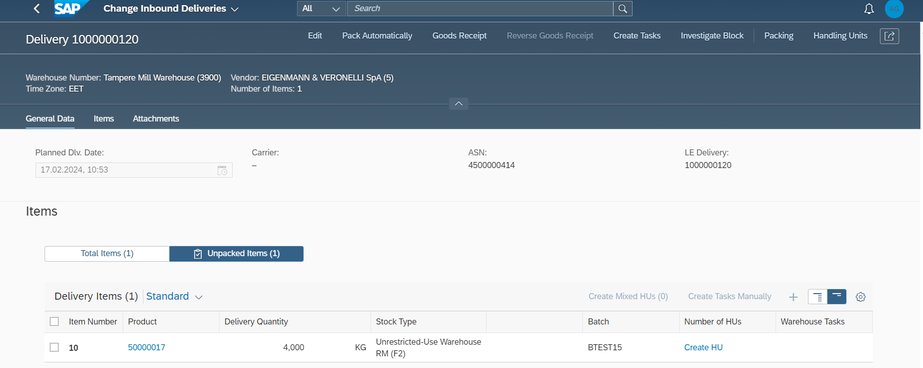

* Logon in the RF screen framework using transaction code /SCWM/RFUI and click on new added custom button   
  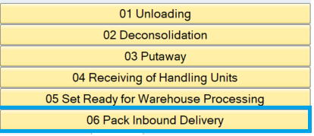
* Enter either PO/ASN or Inbound Delivery and press enter.

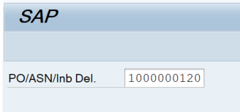

* Now on enter press if the provided input found as duplicate then below screen will appear to check on the provided input from the user.

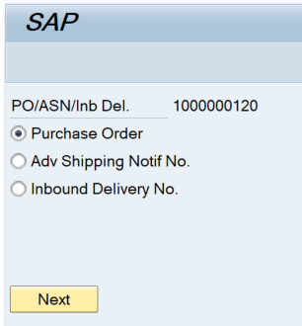

* If multiple inbound deliveries found against the PO or ASN number, then user is asked to provide the appropriate IBD to be processed.

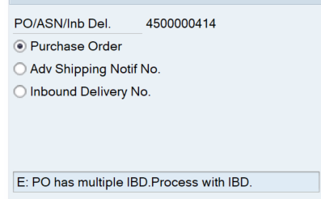

* If valid Inbound delivery found, then below screen will appear.

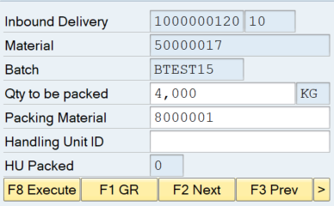  Click on more button to see more available function codes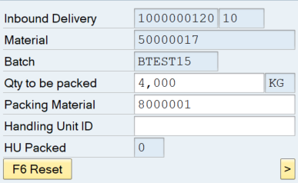

Below are the supported function codes in this screen.

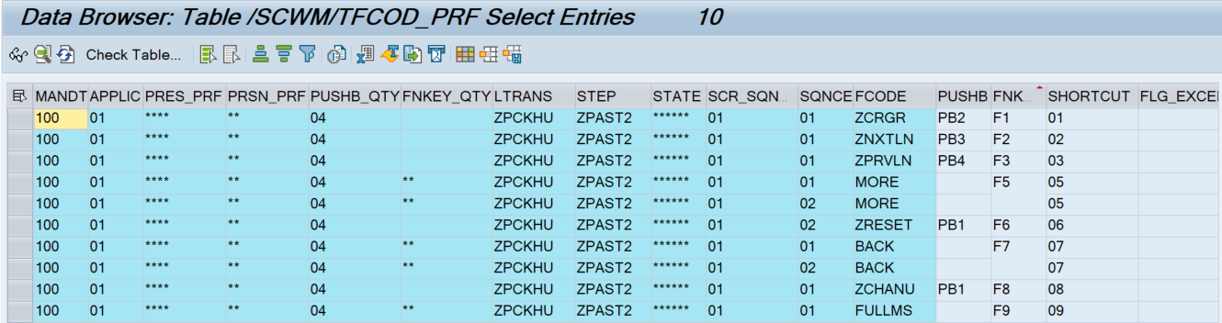

* Pack 1 KG quantity per HU out of total 4KG to be packed.

Change the quantity to be packed as 1 KG and provide the supplier handling unit number and click on Execute button to create the HU and pack the stock.

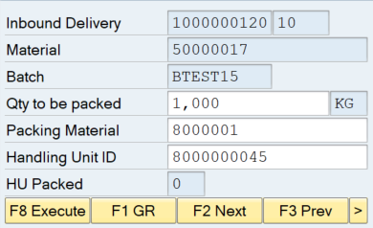

1 HU successfully created and the quantity to be packed is reduced to 3 KG  
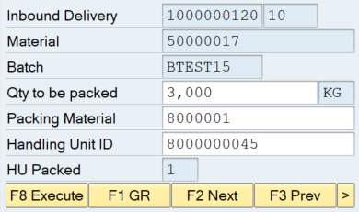

Tcode:/SCWM/PRDI

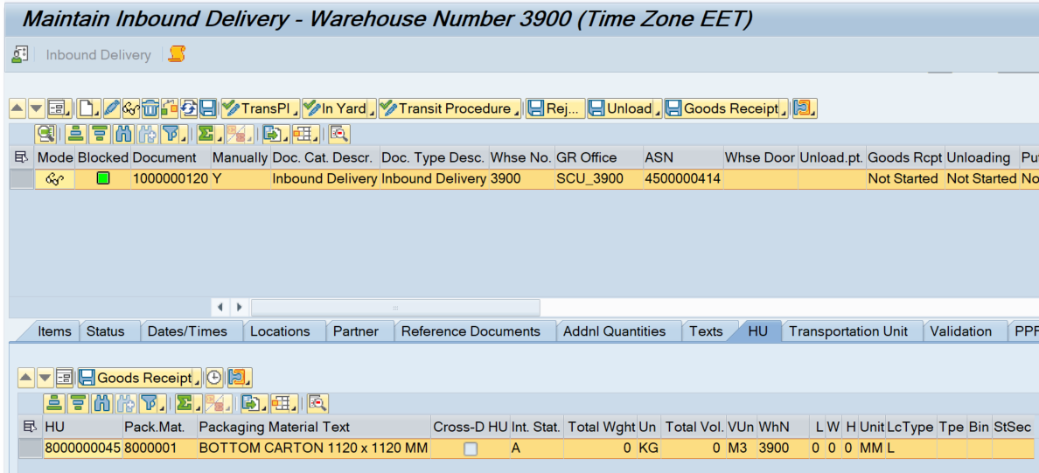

* Create 2nd HU

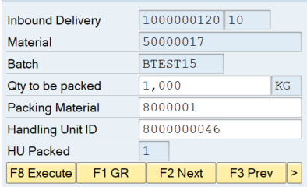  HU created and packed  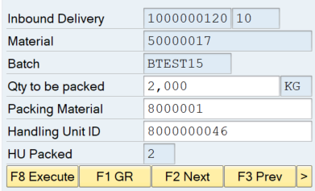

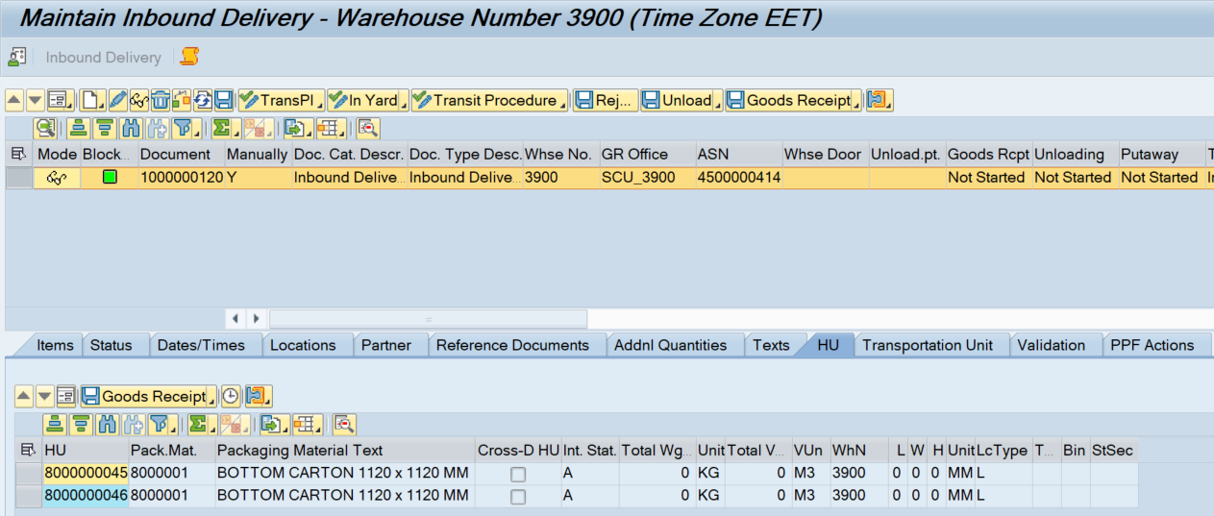

* Create 3rd HU

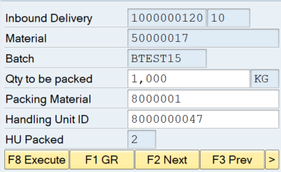 HU created and packed 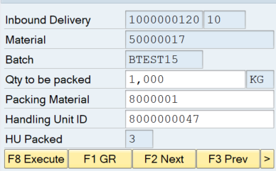

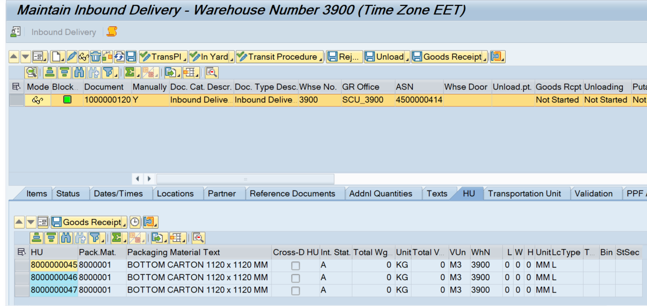

* Create 4th HU

 HU created and packed  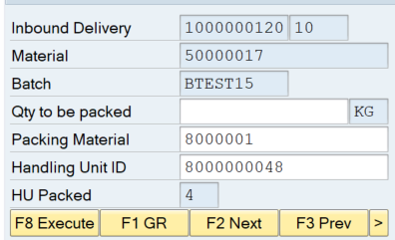

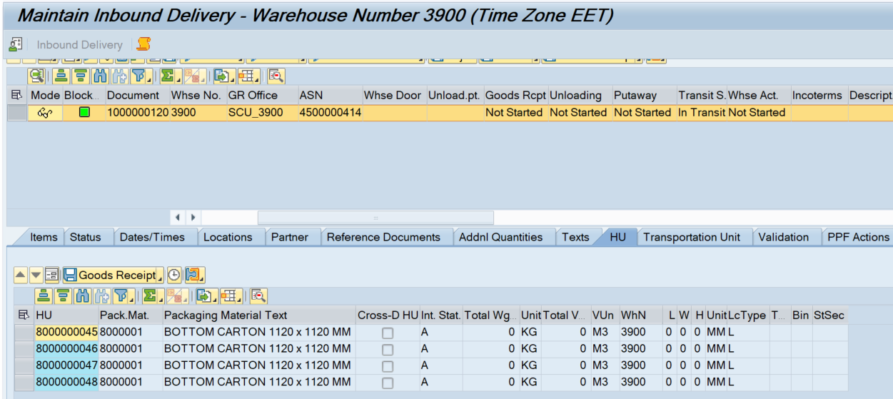

* Click on GR button to post the GR followed by creation and confirmation of Warehouse task.

Before status  
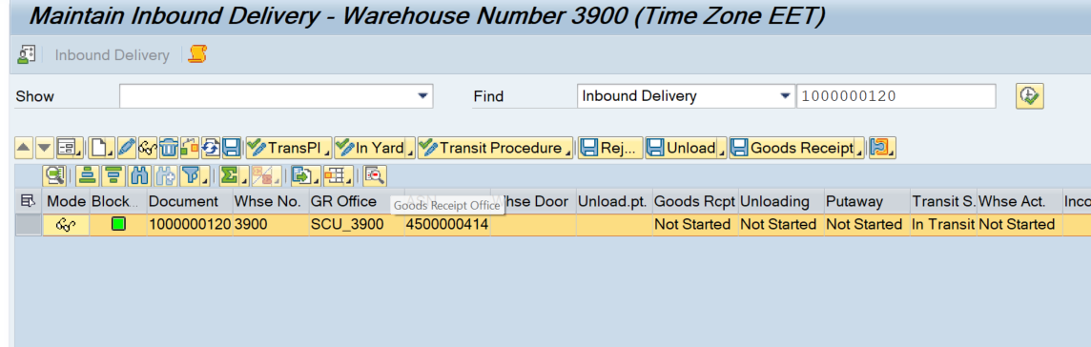

After status

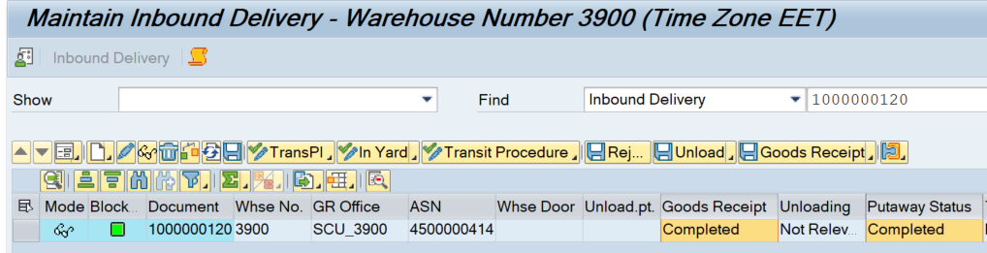

GR documents created  
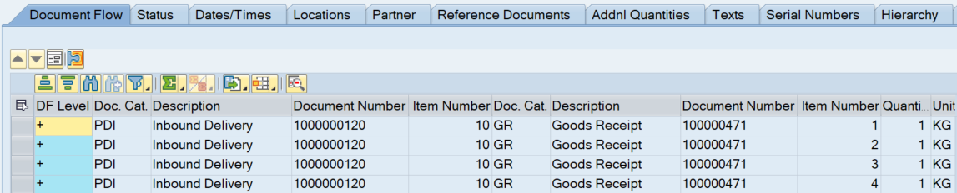  
  
Put away documents created  
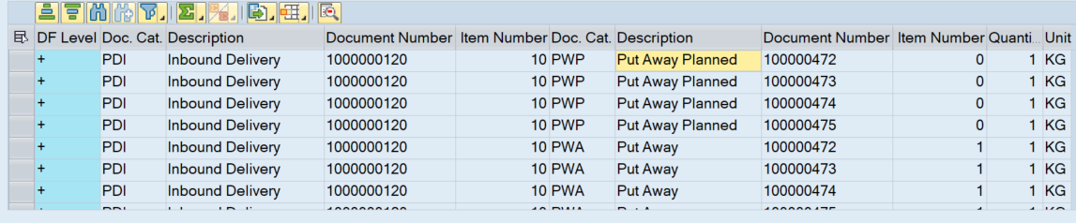  
  
If user again try to create the HU below error message will come from standard as shown below  
